Before take transaction log file backup first change simple to full

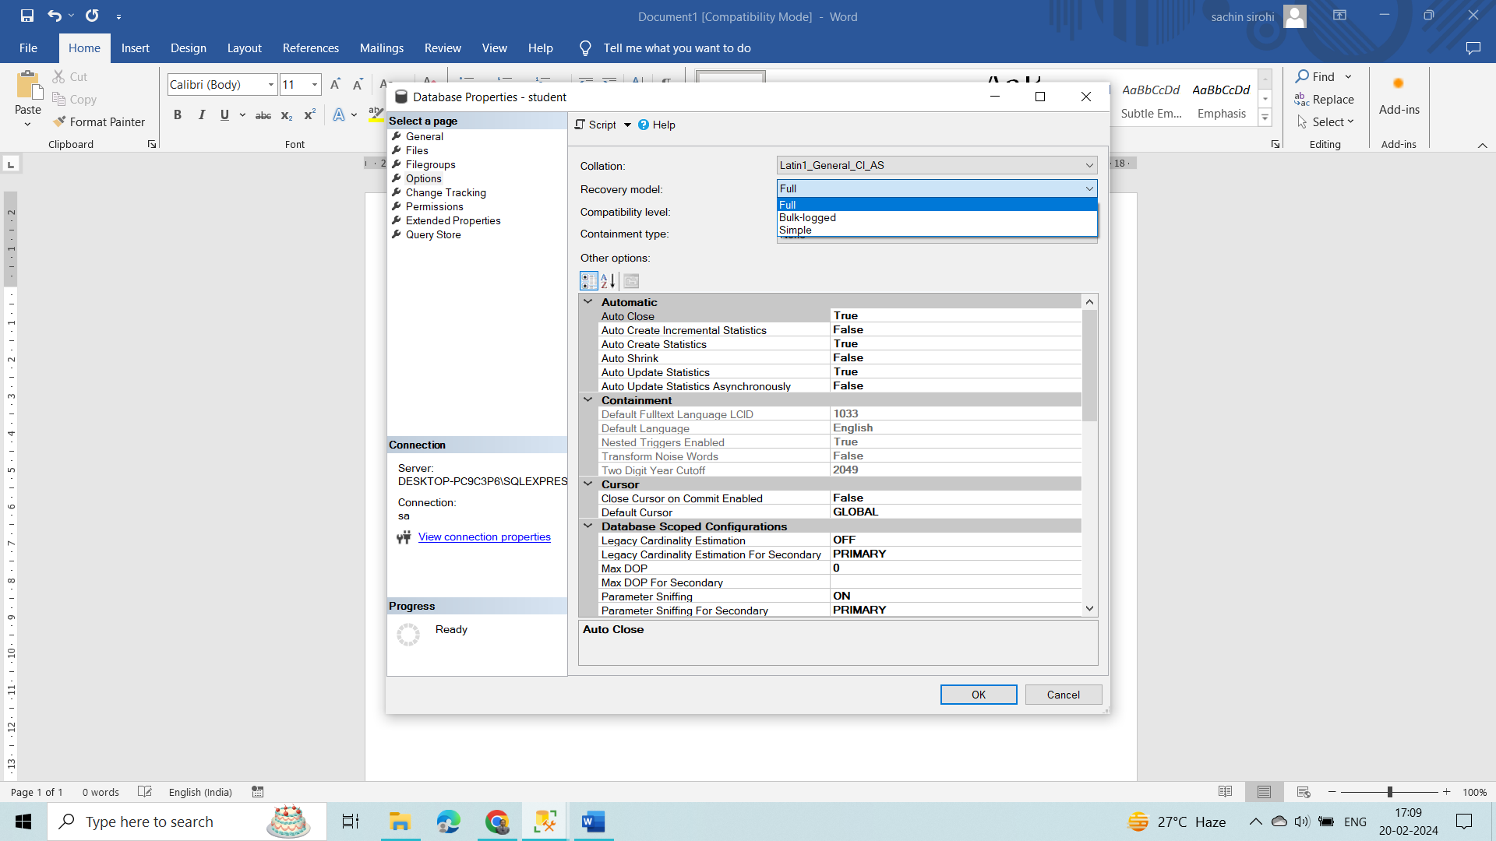

BACKUP DATABASE student

TO DISK = 'C:\Program Files\Microsoft SQL Server\MSSQL16.SQLEXPRESS\MSSQL\Backup\Recover_Deleted_Data.bak'

GO

-- LOG Backup

BACKUP LOG student

TO DISK = 'C:\Program Files\Microsoft SQL Server\MSSQL16.SQLEXPRESS\MSSQL\Backup\Recover_Deleted_Data.trn'

GO

https://www.linkedin.com/pulse/steps-recover-deleted-data-from-sql-table-using-transaction-/